Experiment No. 1: Version Control using Git and GitHub
Aim:To perform basic Git operations such as repository initialization, adding files, committing changes, pushing, pulling, cloning repositories, creating branches, and merging branches using Git and GitHub.
Theory
In this experiment, we will learn how to use Git and GitHub for version control. We will create a new Git repository, add project files, save changes using commits, and upload the project to GitHub. We will also learn how to download updates, clone a repository, create separate branches to develop new features, merge those changes into the main branch, and manage the project efficiently. This experiment helps students understand how developers track code changes, collaborate with team members, and maintain different versions of software in real-world DevOps projects.
What is Version Control?
Version Control is a system that records changes made to files over time. It helps developers keep track of modifications, collaborate with team members, and restore previous versions if required.
Example
Suppose three developers are working on the same project.
- Developer A works on the Login page.
- Developer B works on the Dashboard.
- Developer C fixes bugs.
Version control keeps all these changes organized and prevents files from being overwritten.
What is Git?
Git is a distributed version control system (DVCS) developed by Linus Torvalds in 2005. It is used to track changes in source code and allows multiple developers to work on the same project efficiently.
Features of Git
- Tracks file changes.
- Maintains project history.
- Supports collaboration.
- Allows rollback to previous versions.
- Supports branching and merging.
- Works offline.
What is GitHub?
GitHub is a cloud-based platform that hosts Git repositories online. It enables developers to store, share, and collaborate on projects using Git.
Workflow Explanation
- Working Directory: The folder where you create or edit files.
- Staging Area: Files are prepared for committing using git add.
- Local Repository: Changes are permanently saved using git commit.
- Remote Repository: Changes are uploaded to GitHub using git push.
Requirements
- Git installed
- GitHub account
- Internet connection
- Git Bash / VS Code Terminal
Procedure:
Step 1: Create Project Folder
mkdir GitLab
cd GitLab
Purpose: Creates a new project folder and moves into it.
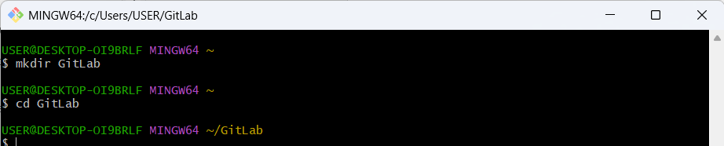

Step 2: Initialize Git Repository
git init
Purpose: Initializes a new Git repository by creating a hidden .git folder.
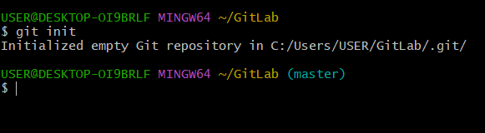
Step 3: Configure Git
git config --global user.name "Your Name"
git config --global user.email yourmail@gmail.com
Purpose: Configures your username and email for Git commits.
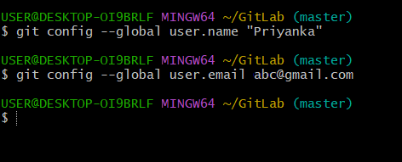
Step 4: Create a File
echo "Hello DevOps" > hello.txt
Purpose: Creates a new file named hello.txt with sample content.
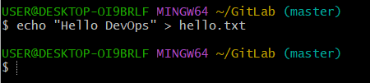
Step 5: Check Repository Status
git status
Purpose: Displays the current status of the repository and shows untracked or modified files
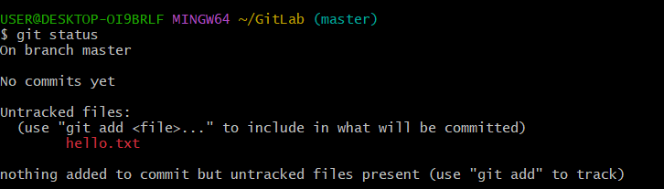
Step 6: Add File to Staging Area
git add hello.txt
Purpose: Adds the file(s) to the staging area for the next commit.
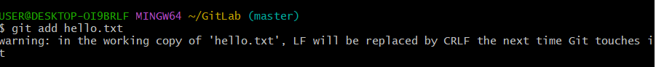
Step 7: Commit Changes
git commit -m "Added hello file"
Purpose: Saves the staged changes into the local repository with a commit message.
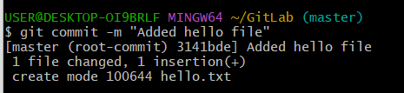
Step 8: View Commit History
git log --oneline
Purpose: Displays the commit history in a concise format.
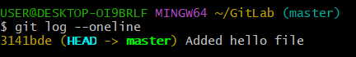
Step 9: Create Repository on GitHub
- Log in to GitHub.
- Click New Repository.
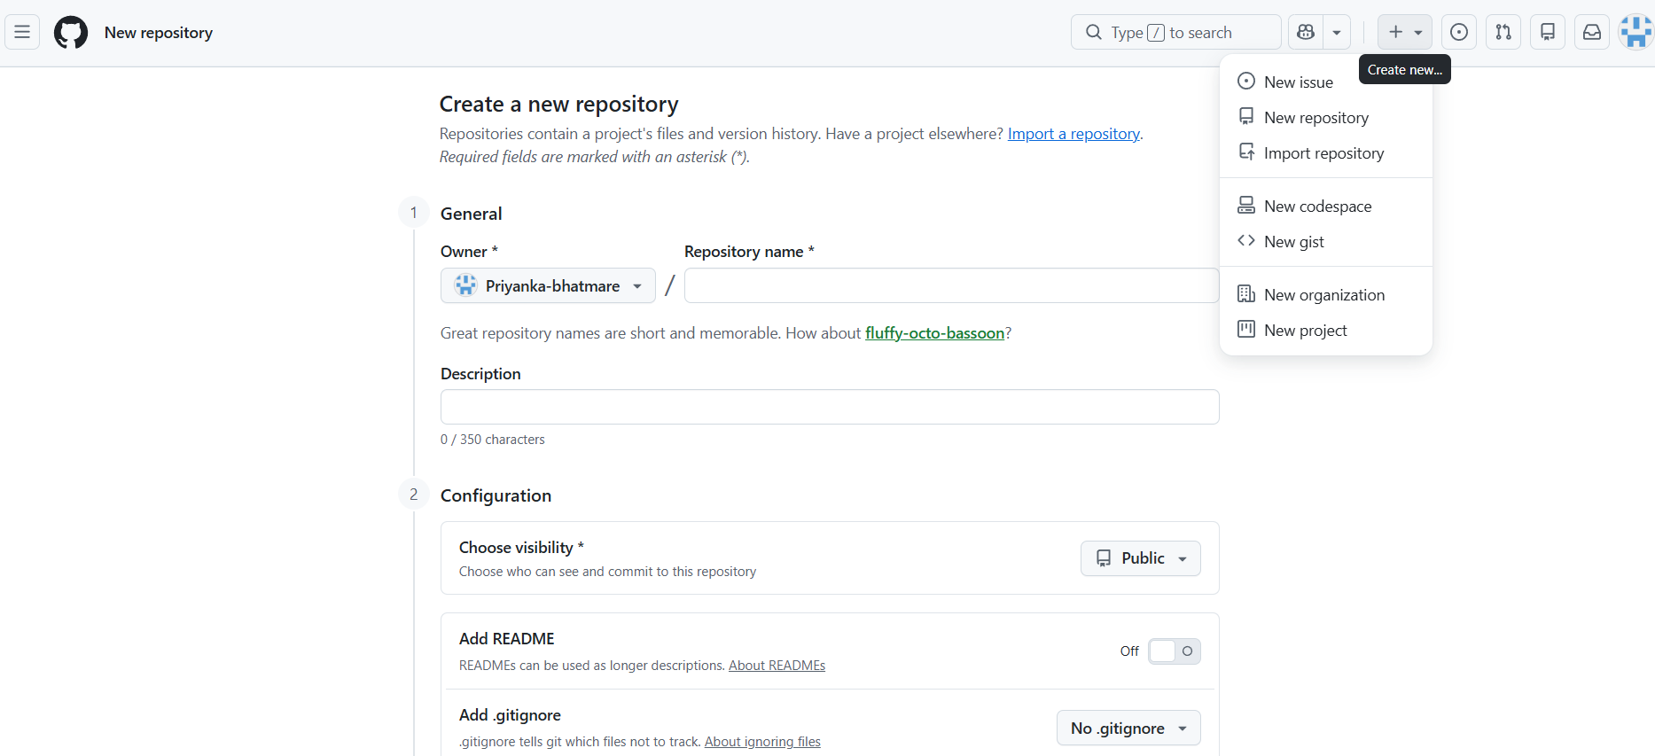
- Enter the repository name (e.g., GitLab).
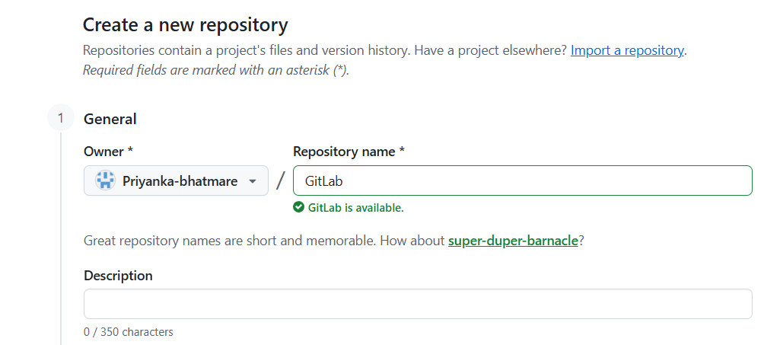
- Click Create Repository.
Purpose: Creates a remote repository to store the project online.

Step 10: Connect Local Repository to GitHub
git branch -M main
git remote add origin https://github.com/your-username/GitLab.git
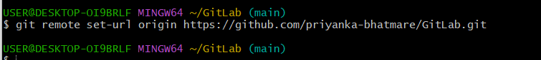
Verify:
git remote -v
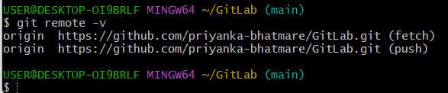
Purpose: Links the local repository with the GitHub repository.

Step 11: Push Changes to GitHub
git push -u origin main
Purpose: Uploads the local repository to GitHub.
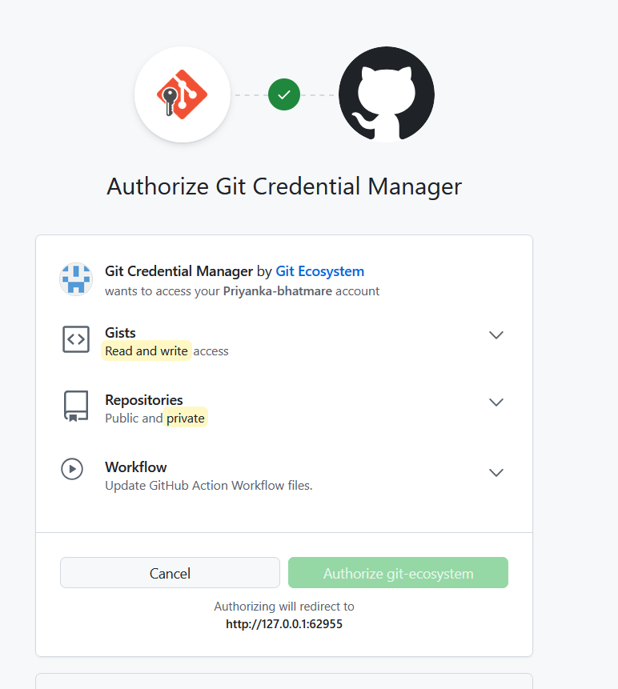
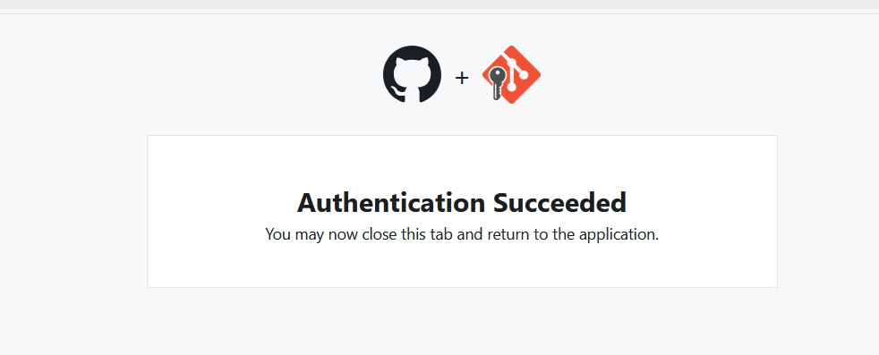

Step 12: Pull Latest Changes
git pull origin main
Purpose: Downloads and merges the latest changes from GitHub into the local repository.
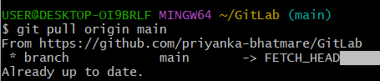
Step 13: Clone Repository
cd ..
git clone https://github.com/your-username/GitLab.git
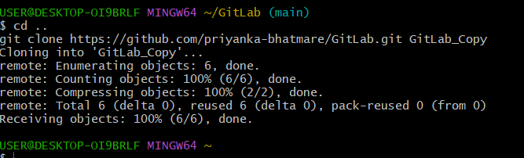
Purpose: Creates a local copy of the GitHub repository.

Step 14: Create a Branch
cd GitLab_Copy
git branch feature1
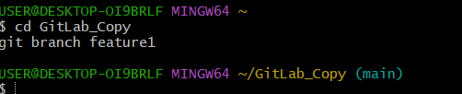
Check branches:
git branch
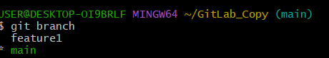
Purpose: Creates a new branch named feature1 for independent development.
Step 15: Switch Branch
git checkout feature1
Purpose: Switches to the newly created branch.
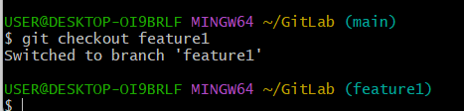
Step 16: Modify the File
echo "Learning Git Branch" >> hello.txt
git add .
git commit -m "Updated hello file"
Purpose: Updates the file and saves the changes in the feature1 branch.
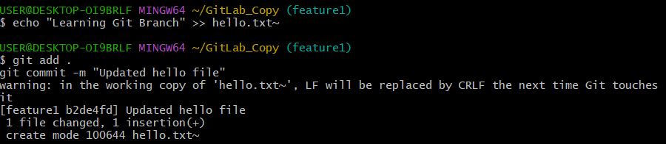
Step 17: Merge Branch
git checkout main
git merge feature1
Purpose: Merges the changes from feature1 into the main branch.
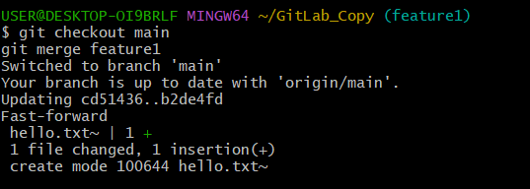
Step 18: Push Merged Changes
git push origin main
Purpose: Uploads the merged changes to GitHub.
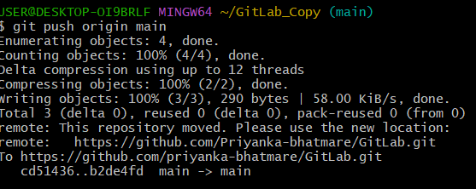
Step 19: Delete the Branch
git branch -d feature1
Purpose: Deletes the local branch after it has been merged.
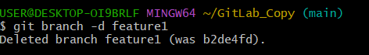
Result
Successfully performed the basic Git operations, including repository initialization (git init), adding files (git add), committing changes (git commit), pushing (git push), pulling (git pull), cloning (git clone), creating branches (git branch), switching branches (git checkout/git switch), and merging branches (git merge), thereby understanding version control using Git and GitHub.

Experiment No. 2: Collaborative Workflow using Git Feature Branches, Pull Requests and Merge Conflict Resolution
Aim
To simulate a software development team using Git feature branches, pull requests, code reviews, and merge conflict resolution.
Theory
Modern software projects are developed by multiple developers working on different features simultaneously. Git provides a collaborative workflow that allows developers to work independently using branches while maintaining a stable main project.
In this experiment, students will simulate a software development team where each member develops a different feature in a separate branch. After completing their work, the branches will be merged into the main branch using Pull Requests. Students will also learn how merge conflicts occur and how to resolve them.
This workflow is widely used in software companies such as Google, Microsoft, Amazon, Infosys, TCS, Accenture, and many open-source projects.
Learning Objectives
After completing this experiment, students will be able to:
- Understand collaborative software development.
- Create and manage feature branches.
- Push feature branches to GitHub.
- Create and merge Pull Requests.
- Resolve merge conflicts.
- Work using an industry-standard Git workflow
What is GitFlow?
GitFlow is a branching strategy where different branches are used for different purposes.
What is Trunk-Based Development?
In Trunk-Based Development, developers work on small feature branches or directly on the main branch (trunk).
Features are merged frequently (daily).
Advantages:
- Faster integration
- Less merge conflicts
- Continuous Integration
- Continuous Deployment (CI/CD)
Requirements
- Git installed
- GitHub account
- Internet connection
- Git Bash or VS Code Terminal
Scenario
Suppose a team is developing a Student Management System.
Team Member | Responsibility | Branch Name
Student A | Login Module | feature-login
Student B | Dashboard Module | feature-dashboard
Student C | Attendance Module | feature-attendance
Each student develops their feature independently.
Procedure:
Step 1 : Add Member:
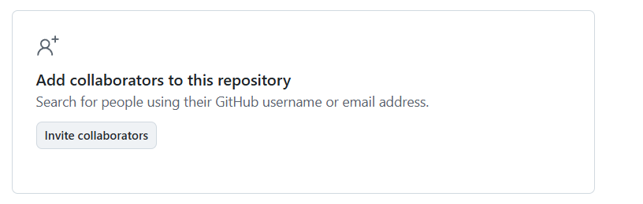

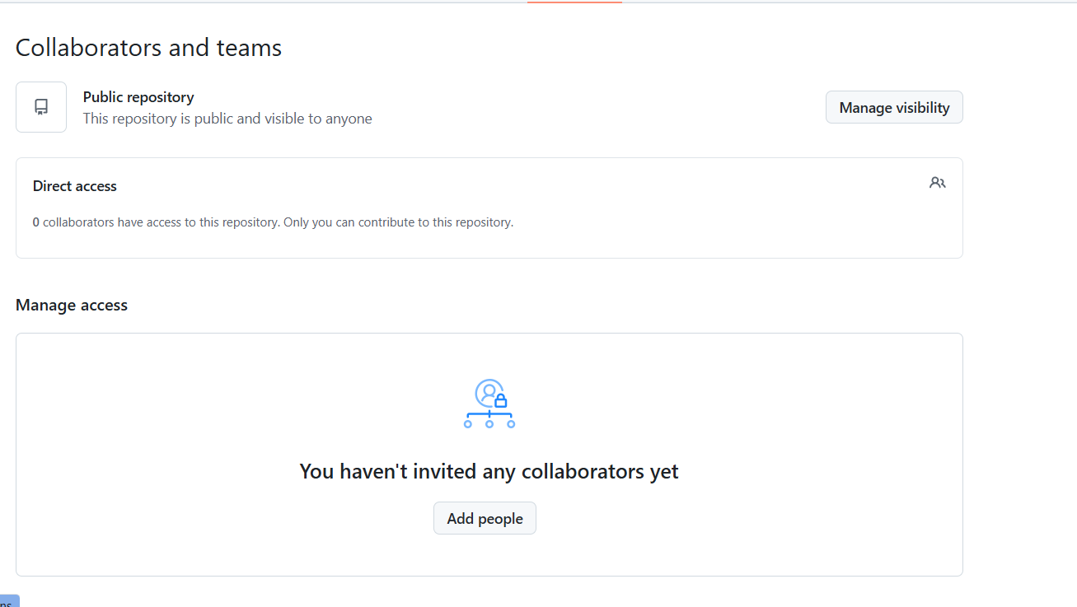
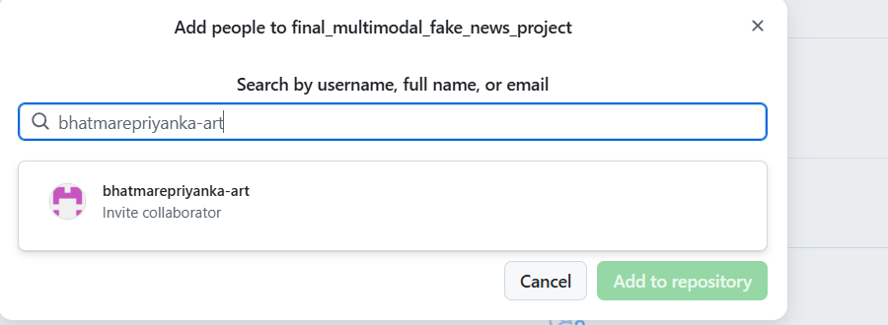
On the Member side, accept the request
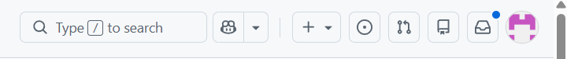
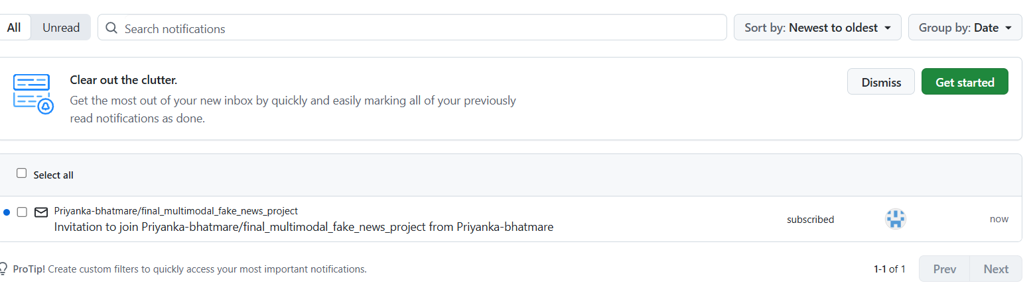

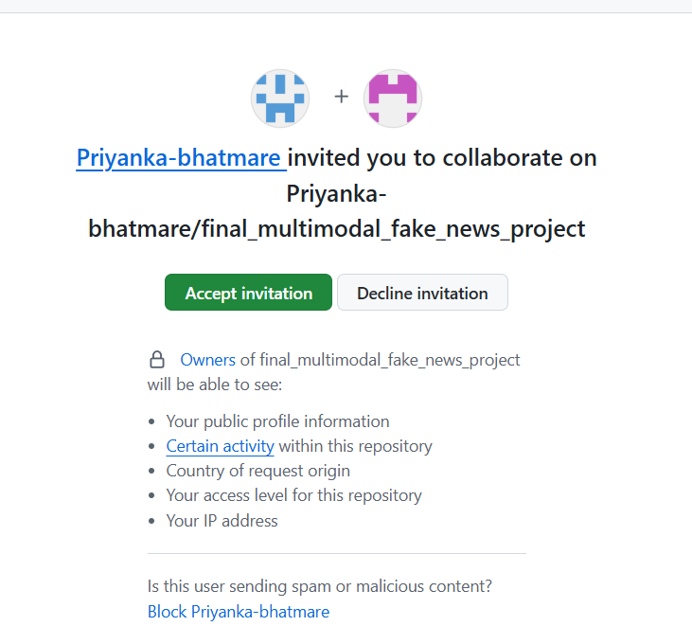

Step 2: Clone The Project
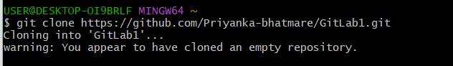

Change Directory:
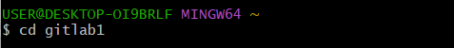

Make Changes:
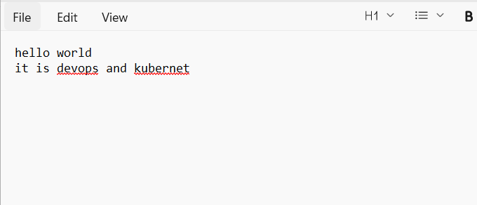
Step 3:Add File
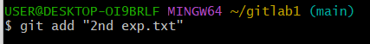
Step 4:Check Status
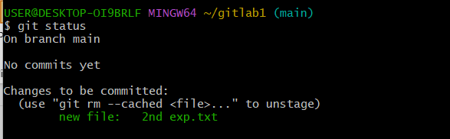
Step 5: Push the file
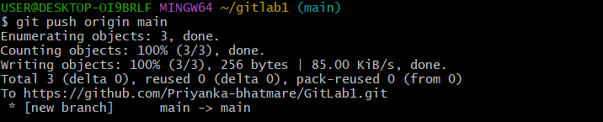

Step 6:After one teammate pushes the project, another teammate needs to check
git pull origin main

